**Student Name**

Ashish Kumar

**EXPERIMENT**

**UID:**22BET10194

**Branch:** BE -IT **Section/Group:**22BET_IOT-703(A)

**Semester:** 6th **Subject Code:** 22ITP-351

# PROBLEM-1

**AIM:-**

Print linked list

**CODE:-**

class Node { int data; Node next;

Node(int data) { this.data = data; this.next = null;

}

}

class Solution {

void printList(Node head) { Node temp = head;

while (temp != null) { System.out.print(temp.data + " "); temp = temp.next;

}

System.out.println();

}

}

public class Main {

public static void main(String[] args) { Node head = new Node(49); head.next = new Node(10); head.next.next = new Node(30);

Solution sol = new Solution(); sol.printList(head);

}

}

**OUTPUT:-**

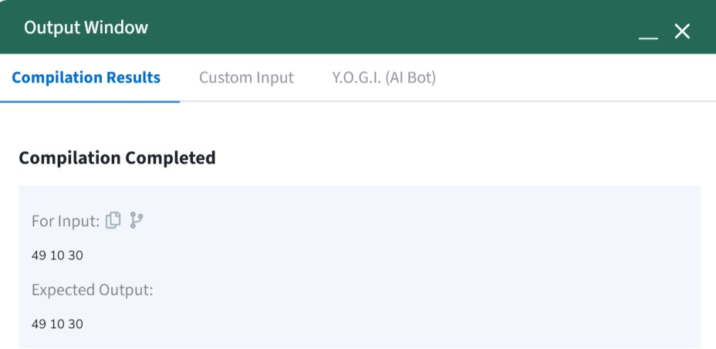

**AIM:-**

**CODE:**-

# PROBLEM-2

Remove duplicates from a sorted list

class Solution {

public ListNode deleteDuplicates(ListNode head) { ListNode res = head;

while (head != null && head.next != null) { if (head.val == head.next.val) {

head.next = head.next.next;

} else {

head = head.next;

}

}

return res;

}

}

**OUTPUT:-**

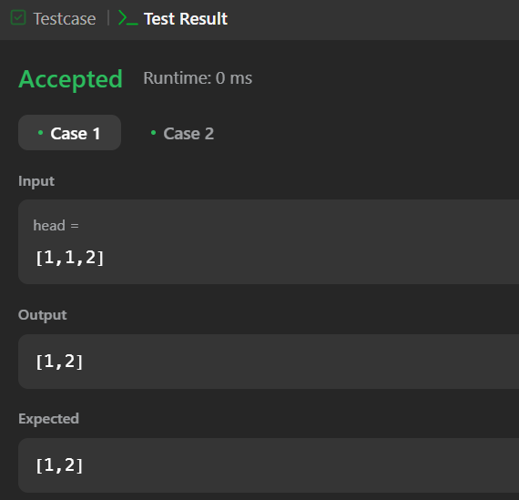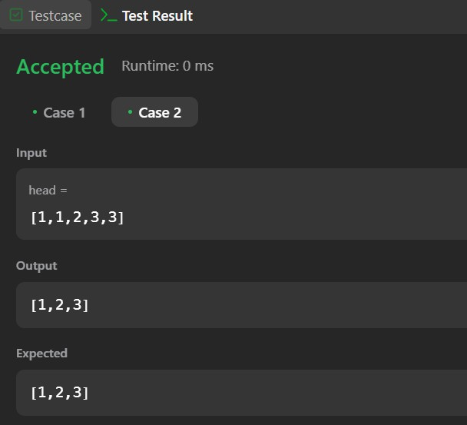

# PROBLEM-3

## AIM:-

Reverse a linked list

## CODE:-

class Solution {

public ListNode reverseList(ListNode head) { ListNode node = null;

while (head != null) { ListNode temp = head.next; head.next = node;

node = head; head = temp;

}

return node;

}

}

**OUTPUT:-**

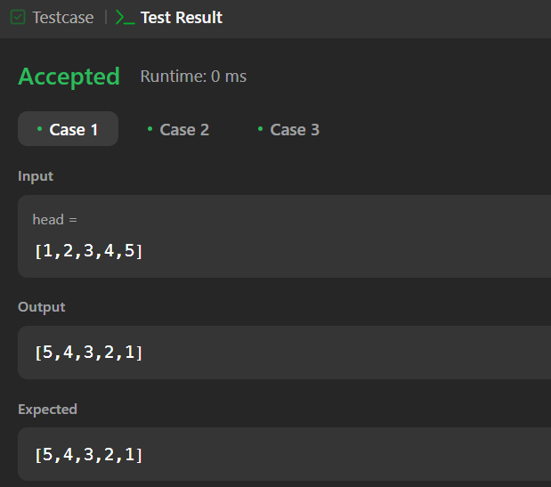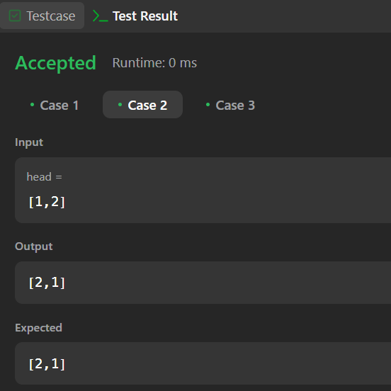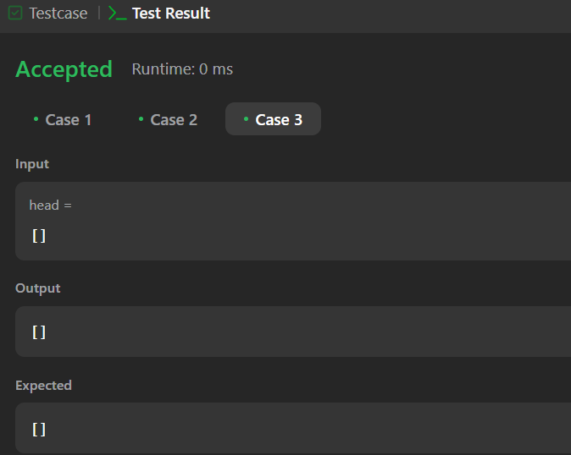

# PROBLEM-4

**AIM:-**

Delete middle node of a list

**CODE:-**

class Solution {

public ListNode deleteMiddle(ListNode head) { ListNode counter = head;

int count = 0; while(counter != null){

counter = counter.next; count++;

}

ListNode curr = head; if(count == 1){

return curr.next;

}

int middle = (count/2) - 1;

count = 0;

while(count != middle){ curr = curr.next; count++;

}

curr.next = curr.next.next; return head;

}

}

**OUTPUT:-**

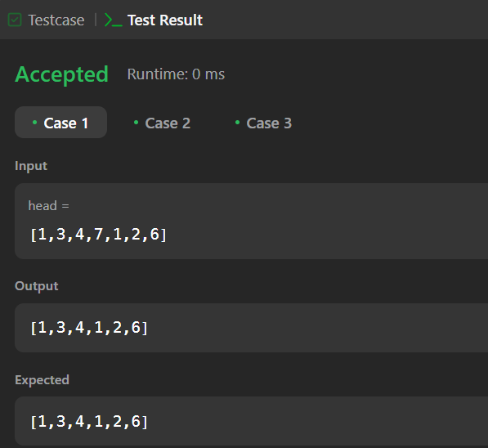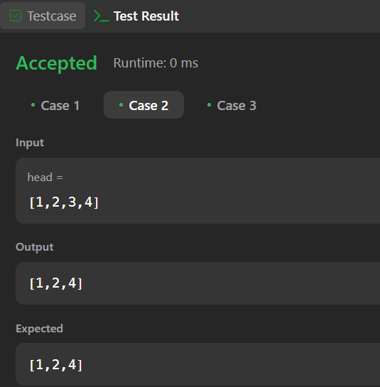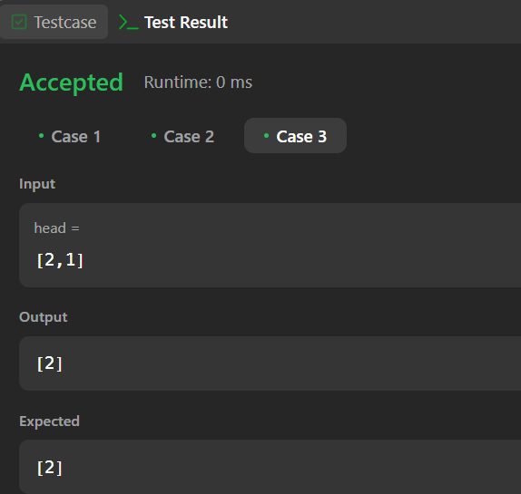

# PROBLEM-5

**AIM:-**

Merge two sorted linked lists

**CODE:-**

class Solution {

public ListNode mergeTwoLists(ListNode list1, ListNode list2) { ListNode dummy = new ListNode();

ListNode cur = dummy;

while (list1 != null && list2 != null) { if (list1.val > list2.val) {

cur.next = list2; list2 = list2.next;

} else {

cur.next = list1; list1 = list1.next;

}

cur = cur.next;

}

cur.next = (list1 != null) ? list1 : list2;

return dummy.next;

}

}

**OUTPUT:-**

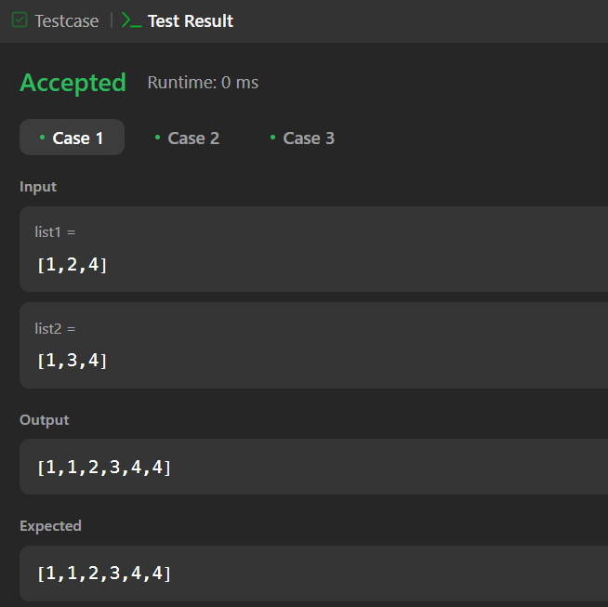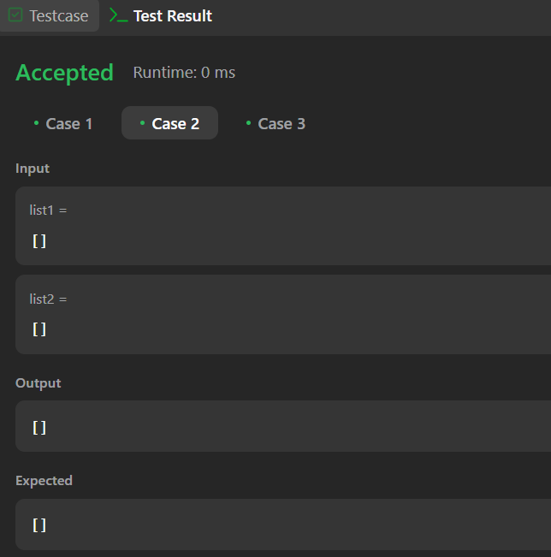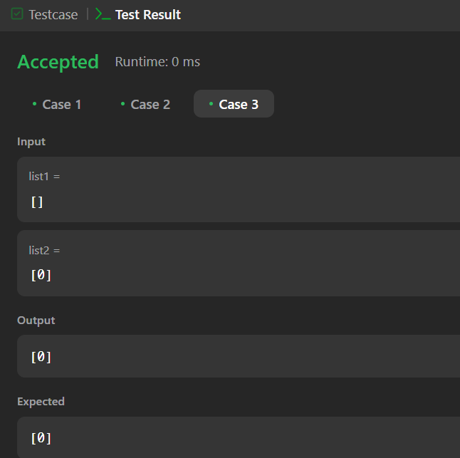

# PROBLEM-6

**AIM:-**

Remove duplicates from sorted lists 2

**CODE:-**

class Solution {

public ListNode deleteDuplicates(ListNode head) { ListNode ans = new ListNode(1000, head); ListNode cur = ans;

while (cur.next != null && cur.next.next != null) { if (cur.next.val == cur.next.next.val) {

int val = cur.next.val;

while (cur.next != null && cur.next.val == val) { cur.next = cur.next.next;

}

} else {

cur = cur.next;

}

}

return ans.next;

}

}

**OUTPUT:-**

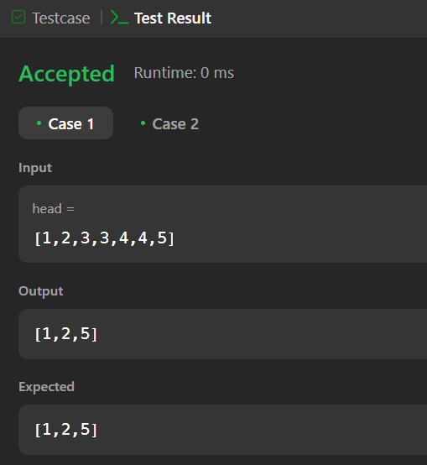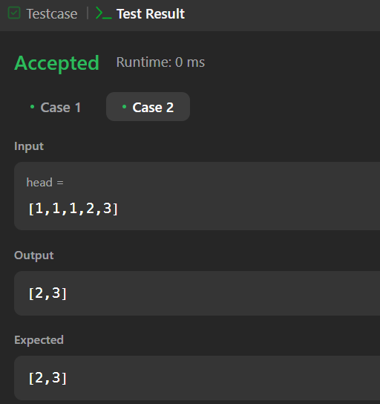

# PROBLEM-7

**AIM:-**

Detect a cycle in a linked list

**CODE:-**

public class Solution {

public boolean hasCycle(ListNode head) { ListNode fast = head;

ListNode slow = head;

while (fast != null && fast.next != null) { fast = fast.next.next;

slow = slow.next;

if (fast == slow) { return true;

}

}

return false;

}

}

**OUTPUT:-**

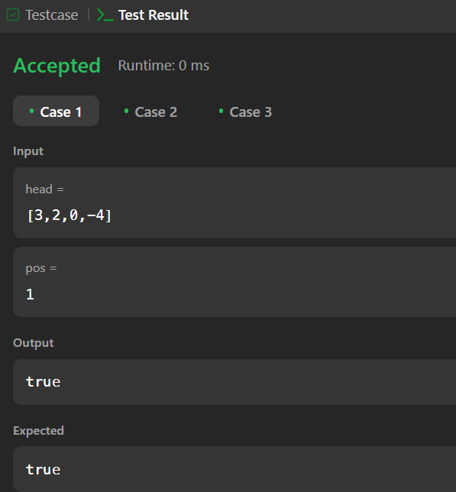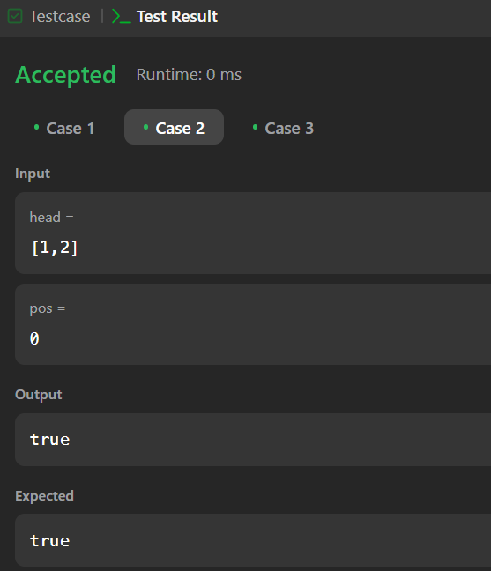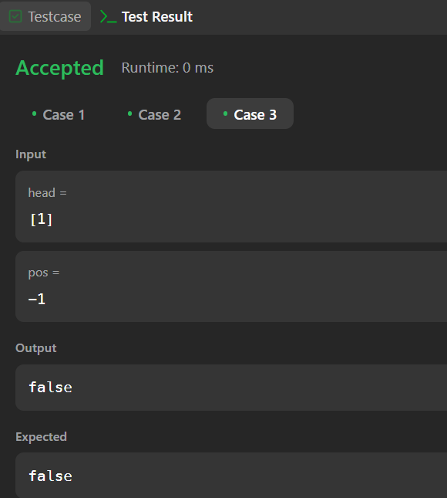

# PROBLEM-8

**AIM:-**

Reverse linked list 2

**CODE:-**

class Solution {

public ListNode reverseBetween(ListNode head, int left, int right) { if (head == null || left == right) {

return head;

}

ListNode dummy = new ListNode(0); dummy.next = head;

ListNode prev = dummy;

for (int i = 0; i < left - 1; i++) { prev = prev.next;

}

ListNode cur = prev.next;

for (int i = 0; i < right - left; i++) {

ListNode temp = cur.next; cur.next = temp.next; temp.next = prev.next; prev.next = temp;

}

return dummy.next;

}

}

**OUTPUT:-**

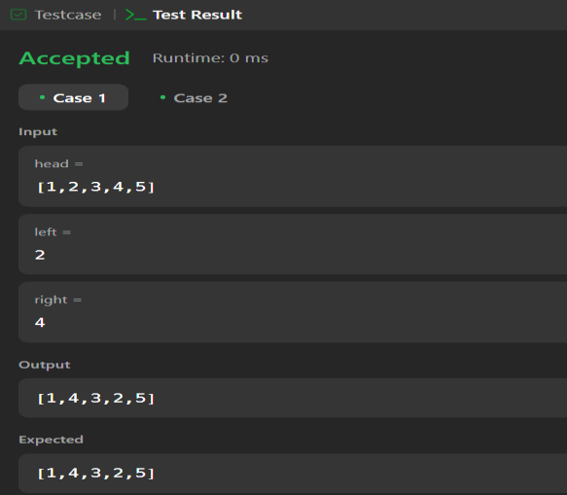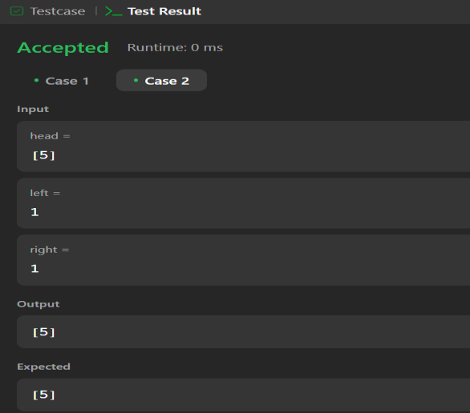

# PROBLEM-9

**AIM:-**

Rotate a list

**CODE:-**

class Solution {

public ListNode rotateRight(ListNode head, int k) { if (head == null || head.next == null || k == 0) {

return head;

}

int length = 1; ListNode temp = head;

while (temp.next != null) { temp = temp.next; length++;

}

temp.next = head; k = k % length;

k = length - k; while (k-- > 0) {

temp = temp.next;

}

head = temp.next; temp.next = null; return head;

}

}

**OUTPUT:-**

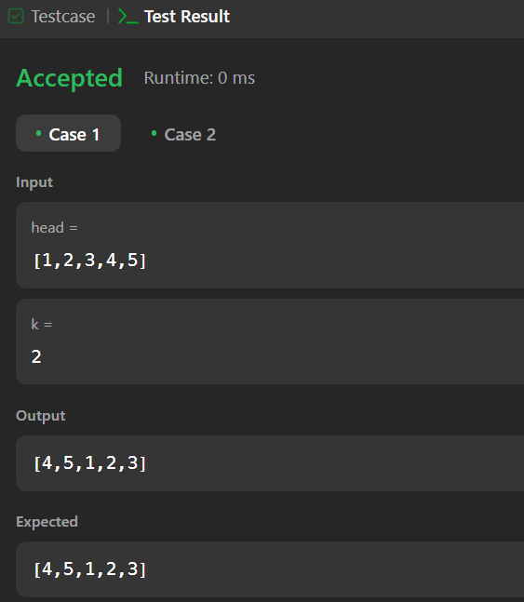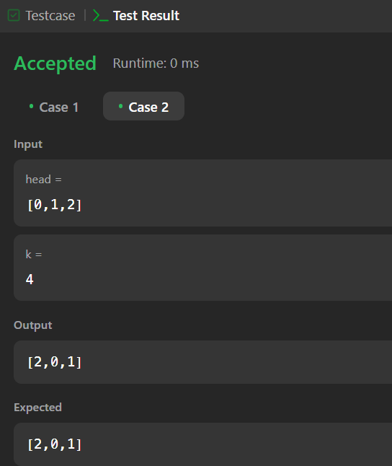

# PROBLEM-10

**AIM:-**

Merge k sorted lists

**CODE:-**

class Solution {

public ListNode mergeKLists(ListNode[] lists) { if (lists == null || lists.length == 0) {

return null;

}

return mergeKListsHelper(lists, 0, lists.length - 1);

}

private ListNode mergeKListsHelper(ListNode[] lists, int start, int end) { if (start == end) {

return lists[start];

}

if (start + 1 == end) {

return merge(lists[start], lists[end]);

}

int mid = start + (end - start) / 2;

ListNode left = mergeKListsHelper(lists, start, mid); ListNode right = mergeKListsHelper(lists, mid + 1, end); return merge(left, right);

}

private ListNode merge(ListNode l1, ListNode l2) { ListNode dummy = new ListNode(0);

ListNode curr = dummy;

while (l1 != null && l2 != null) { if (l1.val < l2.val) {

curr.next = l1; l1 = l1.next;

} else {

curr.next = l2; l2 = l2.next;

}

curr = curr.next;

}

curr.next = (l1 != null) ? l1 : l2; return dummy.next;

}

}

**OUTPUT:-**

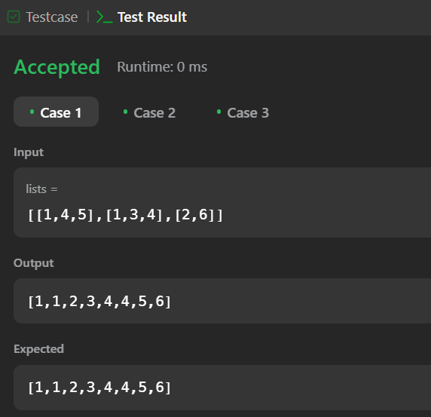

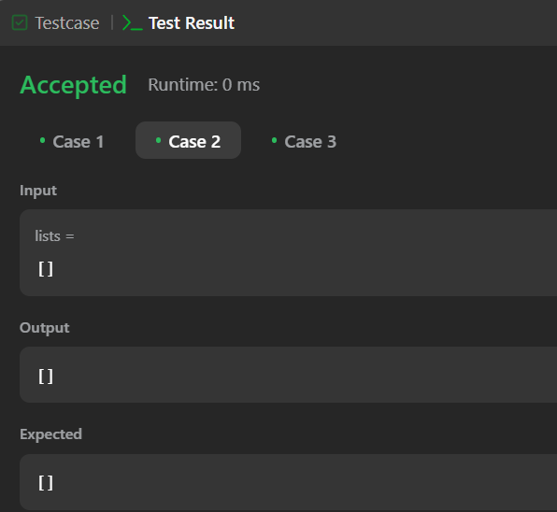

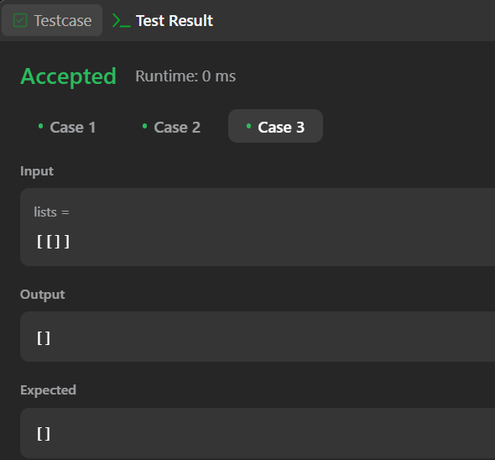

# PROBLEM-11

**AIM:-**

Sort List

**CODE:-**

class Solution {

public ListNode sortList(ListNode head) {

if (head == null || head.next == null) return head; ListNode slow = head, fast = head.next;

while (fast != null && fast.next != null) { slow = slow.next;

fast = fast.next.next;

}

ListNode mid = slow.next; slow.next = null;

ListNode left = sortList(head); ListNode right = sortList(mid); return merge(left, right);

}

private ListNode merge(ListNode l1, ListNode l2) { ListNode dummy = new ListNode(0);

ListNode tail = dummy;

while (l1 != null && l2 != null) { if (l1.val < l2.val) {

tail.next = l1; l1 = l1.next;

} else {

tail.next = l2; l2 = l2.next;

}

tail = tail.next;

}

tail.next = (l1 != null) ? l1 : l2; return dummy.next;

}

}

**OUTPUT:-**

